

MATHEMATICS
YEAR 8

Investigation – Optimisation of Area
Semester 2 2015

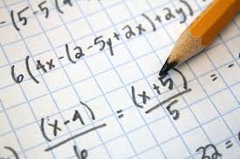

Information for Students

Working time: 45 minutes
Marks available: 52 marks

You have been given the task of designing a series of chook runs. In each situation you will be provided with a different length of chicken wire with which to construct a rectangular run.

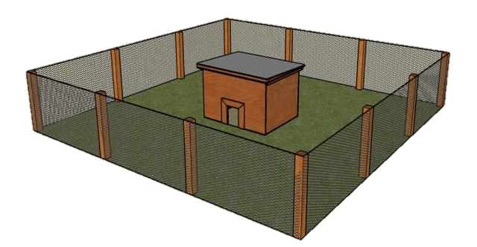
Situation One (13 marks)

You have 20 metres of chicken wire and you need to enclose a rectangular run.

Draw diagrams showing five different sized regions that you could make with the 20 metres of chicken wire. For each region show the dimensions and the area of the region.

Which of your regions, above, has the greatest area? Can you draw a region with a greater area?

Situation Two (13 marks)

You have 50 metres of chicken wire and you need to enclose a rectangular run.

Draw diagrams showing five different sized regions that you could make with the 50 metres of chicken wire. For each region show the dimensions and the area of the region.

Which of your regions, above, has the greatest area? Can you draw a region with a greater area?

Situation Three (13 marks)

In this new situation you are provided with 30 metres of chicken wire with which to construct 3 sides of this rectangular run, and the fourth side (the length) will be the fence line of the property.

Draw a diagram indicating your understanding of the situation.

Complete the table provided, showing the width (x) of the chicken run, its length (y) and its area (xy).

Width | x | 2 | 3 | 4 | 5 | 6 | 7 | 8 | 9
Length | y
Area | xy

Based on the table, what is the maximum area that the chicken run could enclose and what are its dimensions (length and width)?

Can you draw a region with a greater area?

Situation Four (13 marks)

In this new situation you are provided with 50 metres of chicken wire with which to construct 3 sides of this rectangular run, and the fourth side (the length) will be the fence line of the property.

Draw a diagram indicating your understanding of the situation.

Complete the table provided, showing the width (x) of the chicken run, its length (y) and its area (xy).

Width | x | 2 | 4 | 6 | 8 | 10 | 12 | 14 | 16
Length | y
Area | xy

Based on the table, what is the maximum area that the chicken run could enclose and what are its dimensions (length and width)?

Can you draw a region with a greater area?

End of Investigation

